Topic 1.1 - Organisations


Objectives
1.1 Types of organisations and the environments in which they operate
- How the work environment differs in different organisation types, and the impacts and benefits of different work environments for individuals
- The range of environments in which different organisations operate in and how these environments may affect the organisation’s operation.
- The range of different factors that impact organisation
***
0

Proficiency | Content | To Do and Assessment | Help | Tracker pts | Lesson Gamification
💎 | Flow state  https://www.youtube.com/watch?v=ND4mRQlkM8s | Watch and set yourself a target |  |  | 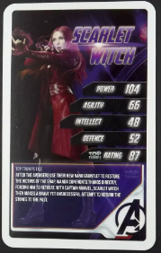
💎 | Plenary | Please send your teacher a Teams message stating:  - Things that have gone well in your learning of late  - Things that you can do improve your learning |  | 9 | 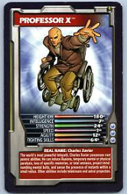
📘 | Notes | Notes on LESSON | Class presentations made available on Teams | 18 | 
🥉 | Interactive whiteboard | Starter Activity:  Define key word &  Brain storm largest organisations |  | 27 | 
🥈 | 🖌️  As we progress: Contribute to this Whiteboard on today's content | https://newcollegeonline-my.sharepoint.com/:wb:/g/personal/mohamed_hamad_newcollege_ac_uk/Ef7Ui-dLNLxFgKqnxy51_y4BL9YX7QVoEKiXy6XtEYcITA?e=thOhAc |  | 36 | 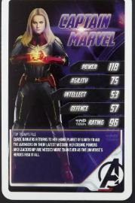
 | Update tracker | Tracker:  Class Tracker.xlsx | Enter your score according to the scores in the column on the right | 45 | 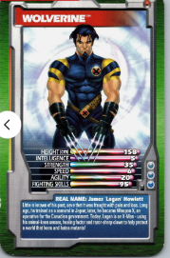
🏆 | Test | https://forms.office.com/Pages/ResponsePage.aspx?id=DlxBAd5R8UGRZkagELnS14FF3zE2k3hFtpmfxmKEI41UMkJTS080RE9GVzY0WURLSkU2RkhUTEU3Uy4u | Send screenshot of your result to your teacher for feedback | 54 | 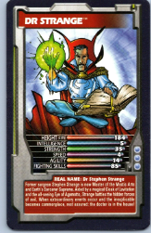
🎓 | Activity | Worksheet Activity:  Handed out |  | 63 | 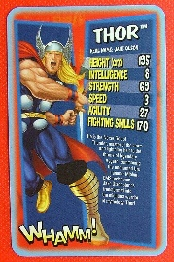
🥇 | Review | Send your teacher a Teams message stating what you have learnt today |  | 72 | 
⭐ | infographic | Create an infographic of the material for today  Send me a screenshot of it | E.g. https://www.canva.com/create/infographics/ | 81 | 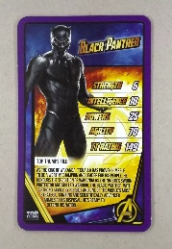
⭐⭐ | Extension work: Learning program | Code a learning program that quizzes you on the material above.  Send me a screenshot of the inputs, code and outputs of the program (in run time) |  | 90 | 
⭐⭐⭐ | Extension Work | Create a and quizlet or kahoot on this lesson's material.  Complete any work set by other teachers. Mentor another student | How to create them:  https://www.youtube.com/watch?v=Jo6ITr9yt4Y&t=24s  https://www.youtube.com/watch?v=S5Qfuz3Y7kY | 100 | 

